**Week – 7**

**React**

**Objectives**

* **Explain about conditional rendering in React**
* **Define element variables**
* **Explain how to prevent components from rendering**

**In this hands-on lab, you will learn how to:**

* **Implement conditional rendering in React applications**

**Prerequisites**

**The following is required to complete this hands-on lab:**

* **Node.js**
* **NPM**
* **Visual Studio Code**

**Notes**

**Estimated time to complete this lab: 60 minutes.**

**Create a React Application named “ticketbookingapp” where the guest user can browse the page where the flight details are displayed whereas the logged in user only can book tickets.**

**The Login and Logout buttons should accordingly display different pages. Once the user is logged in the User page should be displayed. When the user clicks on Logout, the Guest page should be displayed.**

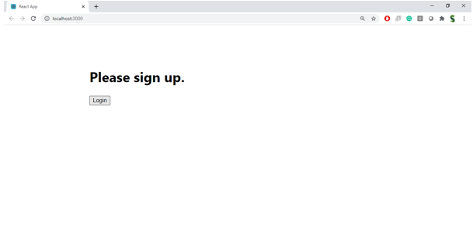

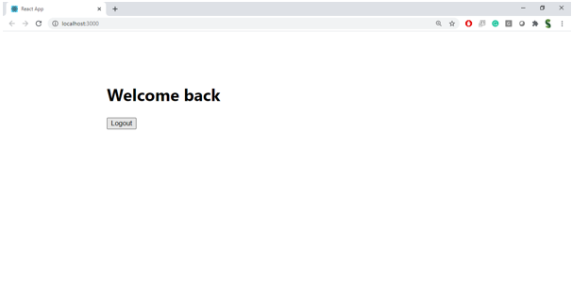

**Hint:**

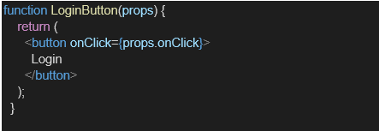

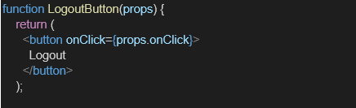

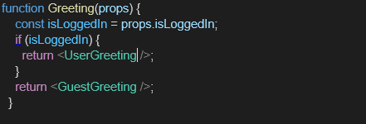

**IMPLEMENTATION :**

import React, { useState } from "react";

import "./App.css";

function GuestPage() {

return (

<div>

<h2>Welcome, Guest!</h2>

<p>Here are the available flights:</p>

<ul>

<li>Flight A - Chennai to Delhi - ₹5,000</li>

<li>Flight B - Mumbai to Kolkata - ₹4,500</li>

<li>Flight C - Bangalore to Goa - ₹3,200</li>

</ul>

<p><i>Login to book tickets.</i></p>

</div>

);

}

function UserPage() {

return (

<div>

<h2>Welcome, User!</h2>

<p>You can now book tickets:</p>

<button>Book Flight A</button>

<button>Book Flight B</button>

<button>Book Flight C</button>

</div>

);

}

function App() {

const [isLoggedIn, setIsLoggedIn] = useState(false);

let pageContent; // Element variable

if (isLoggedIn) {

pageContent = <UserPage />;

} else {

pageContent = <GuestPage />;

}

return (

<div className="App">

<h1>✈ Ticket Booking App</h1>

{pageContent}

<div style={{ marginTop: "20px" }}>

{isLoggedIn ? (

<button onClick={() => setIsLoggedIn(false)}>Logout</button>

) : (

<button onClick={() => setIsLoggedIn(true)}>Login</button>

)}

</div>

</div>

);

}

export default App;

**OUTPUT :**

